IoT REAL WORLD
PROGRAMMABLE BLOCKS
Design and Implementation of a Web-Based Visual and AI-Assisted IoT Automation Platform
A Project Report Submitted in Partial Fulfillment of the Requirements for the Degree of
Bachelor of Science in Computer Science and Engineering
Submitted by
Antor Ahmed
Registration No. 16502000527
Session 2016-17
Supervisor
Md. Shahiduzzaman
Assistant Professor, Department of CSE
Department of Computer Science and Engineering
Dhaka City College
National University
Dhaka, Bangladesh
Revised technical report, September 2026

DECLARATION
I declare that this report describes the IoT programmable-block project and its current implementation to the best of my knowledge. Earlier project material has been revised to distinguish implemented software and firmware from proposed, incomplete, or not-yet-verified work. The final submission should be reviewed and signed by the author and supervisor.
Antor Ahmed
Date: ____________________
Signature: ____________________

ACKNOWLEDGEMENTS
[Author to complete acknowledgements before formal submission.]

ABSTRACT
This project develops an Internet of Things (IoT) programmable block and a web platform for composing device automations. The hardware prototype is based on a Wemos D1 mini with an ESP8266 controller. Its revised circuit exposes connections for a DHT11 sensor, a motion-sensor module, a push button, an LED and a transistor-switched buzzer. A routed PCB layout dated 27 September 2026 documents the current board revision. The web application at https://iot.alsabid.com provides a React and React Flow visual designer for connecting input, sensor, logic and actuator blocks. It presents flow warnings and a generated Python automation script. A PHP JSON API exchanges device state, while embedded firmware provides Wi-Fi setup, local input/output endpoints and remote synchronization. The website also includes an AI chatbot that can write or revise an automation script and apply corresponding changes to the visual designer as an agent. The report describes the architecture, hardware, interfaces, implementation, verification approach and current limitations. In particular, the schematic and checked-in firmware are not yet fully aligned: the schematic includes DHT11 and motion interfaces, whereas the current firmware uses a one-wire temperature sensor on D5 and does not implement motion input. The project is therefore presented as an evolving prototype, with this integration gap and security requirements made explicit.
Keywords: Internet of Things, ESP8266, programmable blocks, visual programming, React Flow, PHP API, Python automation, AI agent

CONTENTS
- Declaration
- Acknowledgements
- Abstract
- Chapter 1 Introduction
- Chapter 2 Background and Enabling Technologies
- Chapter 3 Requirements and System Analysis
- Chapter 4 System and Hardware Design
- Chapter 5 Implementation
- Chapter 6 Verification and Evaluation
- Chapter 7 Conclusion and Future Work
- References
- Appendix A API and Data Reference
- Appendix B Build and Setup Procedure
- Appendix C Figure Insertion Checklist
Page numbers can be refreshed in Word after opening the document. Figure boxes identify project-specific images that should be inserted from original design and application exports.

LIST OF FIGURES
- Figure 3.1. End-to-end system data flow [placeholder]
- Figure 4.1. Layered system architecture [placeholder]
- Figure 4.2. Updated circuit schematic [placeholder]
- Figure 4.3. PCB layout, revision dated 27 September 2026 [embedded local export]
- Figure 5.1. Visual designer canvas and inspector [placeholder]
- Figure 5.2. Generated Python script view [placeholder]
- Figure 5.3. AI chatbot-to-designer interaction [placeholder]
- Figure 6.1. Assembled prototype and test setup [placeholder]

CHAPTER 1

INTRODUCTION

1.1 Background
The Internet of Things connects physical devices, sensors and actuators to software services over local and wide-area networks. A small connected node can observe its environment, publish readings and react to commands. Yet a complete IoT application typically requires several separate skills: selecting and wiring components, writing embedded firmware, exposing an API, configuring a server and implementing the automation logic.
Programmable blocks offer a way to organize these capabilities into reusable physical and software units. A block can expose a small set of named inputs and outputs, while a visual program expresses how signals should be combined. This project extends that idea with a web designer and generated Python automation so that a user can work with the same automation at visual, code and device levels.

1.2 Problem Statement
The project addresses the gap between a physical IoT prototype and an approachable method for defining its behaviour. Direct firmware edits are powerful but can make small changes slow for learners or users who do not routinely program microcontrollers. A graphical workflow can reduce that barrier, but only if its blocks correspond to real device capabilities, generated code stays consistent with the visual representation, and state is exchanged through a defined interface.
A second challenge is integration drift. The current schematic describes DHT11 and motion-sensor interfaces, while the checked-in ESP8266 firmware reads a one-wire temperature sensor and has no motion input. A report that presents these as a single completed feature set would overstate the implementation. This thesis records both the intended hardware design and the current software boundary.

1.3 Aim and Objectives
The aim is to design and document an IoT programmable-block prototype integrated with a web-based visual automation environment and an AI-assisted workflow editor.
- Describe the revised ESP8266-based circuit and PCB, including its sensor, input, indicator and actuator interfaces.
- Document the embedded Wi-Fi setup, local I/O API and remote state synchronization implemented in firmware.
- Describe the PHP JSON API used to list devices and read or update device state.
- Explain how a React and React Flow designer represents workflows and presents generated Python automation.
- Describe the website AI chatbot capability to write or revise automation code and apply corresponding designer changes.
- Identify verification evidence, unresolved integration work, privacy and security risks, and future development priorities.

1.4 Scope
The scope covers the project repository and the public visual designer at https://iot.alsabid.com as observed for this report. It includes the Wemos D1 mini firmware, the PHP API implementation in the repository, the Python IoT client library, the visual flow concepts and the user-reported AI agent behaviour. The available PCB export is included as a project figure.
This report does not claim production certification, security review, measured reliability, validated battery runtime, completed motion sensing in firmware, DHT11 support in firmware, user-study results, or a formally benchmarked AI model. Such claims require additional evidence.

1.5 Contributions
The project contributes an integrated prototype concept linking configurable IoT hardware, a visual workflow editor, generated Python automation, an HTTP state API and a natural-language agent that can update both the script and its visual representation. The rewritten report contributes a consistent description of the current design and distinguishes available implementation from remaining work.

1.6 Report Organization
Chapter 2 introduces the enabling technologies. Chapter 3 defines system requirements and analyzes the workflow. Chapter 4 describes architecture, circuit and PCB design. Chapter 5 records the embedded, API, visual designer, Python and AI-agent implementation. Chapter 6 provides a verification plan and identifies verified versus pending evidence. Chapter 7 summarizes conclusions and future work. The appendices collect API, build and figure-insertion references.

CHAPTER 2

BACKGROUND AND ENABLING TECHNOLOGIES

2.1 Internet of Things Nodes
An IoT node combines a controller, network interface, power source, I/O circuitry and one or more sensors or actuators. The controller reads inputs, maintains local state and communicates through a transport such as HTTP. In this project the ESP8266 class of Wi-Fi microcontroller is used on a Wemos D1 mini board. The design choice provides integrated Wi-Fi and a compact development module; actual GPIO assignments and electrical limits must be checked against the board and module documentation [1, 2].

2.2 Visual Workflow Programming
A visual workflow expresses a program as connected nodes. A node can represent a physical input, a sensor reading, a condition or an actuator action. The web designer uses React for its interface and React Flow for the node-and-edge canvas [3, 4]. The selected block can be configured in an inspector, while flow warnings and generated code provide complementary views of the same automation.
The visual model should be treated as the editable source representation. Generated code is an execution artifact derived from that representation. Keeping identifiers, connection semantics and device assignments stable is important when a chatbot or user edits the flow.

2.3 HTTP APIs and Device State
The platform uses HTTP and JSON to exchange device state. A device record can include a device identifier, LED and buzzer values, button state, temperature and an update timestamp. GET operations read state; update operations accept state values and return a JSON result. HTTP status codes distinguish successful operations from missing arguments, invalid values, disconnected devices and server errors [5].
The repository PHP service stores per-device records as JSON files. This is a lightweight prototype persistence model, not a relational database. The endpoint implementation also enables cross-origin requests broadly; this is convenient for a browser prototype but requires restriction and authentication before production use.

2.4 Python Automation
Python is used as the automation runtime and as a client library for discovering and controlling devices. The checked-in client resolves device hostnames, probes discovery endpoints, reads status and sets outputs over HTTP. It provides typed exceptions for network, API, station-connection and device-discovery errors. The web designer displays generated Python that periodically reads device state, evaluates conditions and writes output changes.
Automation scripts should have explicit lifecycle controls, bounded request timeouts, retry policies, observable logs and a safe shutdown path. These properties are visible in the generated script interface and should be verified for each supported workflow.

2.5 AI-Assisted Editing
The website chatbot is described by the project owner as an agent capable of writing or revising an automation script and updating the visual designer automatically. In this architecture, a natural-language request must be translated into a workflow change, reflected in generated Python and synchronized with the designer state.
AI-generated code can be incorrect, incomplete or unsafe. A robust implementation should validate the structured flow, show the proposed change, preserve undo and history, prevent secrets from being embedded in code, and restrict script execution. This report documents the stated product capability but does not assume a specific language model, provider, prompt design or safety mechanism because those details were not verified.

2.6 Embedded and Web Development Tools
The embedded project is configured with PlatformIO for the Espressif8266 platform and the Arduino framework. The firmware uses the ESP8266 Wi-Fi, HTTP server, HTTP client and mDNS facilities and includes DallasTemperature and OneWire libraries for the currently implemented temperature path [2, 6]. The API is implemented in PHP, and the designer is a React application. Python documentation and the language runtime are relevant to the generated automation layer [7].

CHAPTER 3

REQUIREMENTS AND SYSTEM ANALYSIS

3.1 Stakeholders and Operating Context
The primary user creates or modifies automations through the website. A device owner configures Wi-Fi on the ESP8266 block and connects sensors and actuators. A maintainer deploys the PHP API and manages the host environment. A learner or evaluator may inspect the visual flow, generated code and physical response. The AI chatbot operates as an editing agent on behalf of the user; it should not silently bypass controls applied to ordinary edits.

3.2 Functional Requirements
ID | Requirement | Current status
FR-01 | The ESP8266 provides Wi-Fi access-point setup and can join a configured router. | Implemented in firmware; hardware verification required.
FR-02 | The device exposes discovery and local I/O status endpoints. | Implemented in firmware.
FR-03 | The device can accept LED and buzzer output commands and report button and temperature state. | Implemented for the checked-in pin/sensor mapping.
FR-04 | The PHP API lists device records and supports state reads and updates. | Implemented in the checked-in API.
FR-05 | The visual designer represents input, sensor, logic and actuator blocks. | Available on the website; detailed automated tests not supplied.
FR-06 | The visual flow produces a Python automation script. | Available in the designer UI; generated workflows require regression tests.
FR-07 | The chatbot can write or revise scripts and update the visual designer. | Stated project capability; internal model/agent implementation not inspected.
FR-08 | The revised schematic provides DHT11 and motion-sensor interfaces. | Present in the supplied circuit drawing; firmware integration remains pending.

3.3 Non-Functional Requirements
- Usability: block names and inspector controls should correspond to physical device signals and describe units or accepted values.
- Reliability: transient API failures should not corrupt workflow state or leave outputs unintentionally latched.
- Observability: device connection state, flow warnings, script logs and API outcomes should be visible enough to diagnose failures.
- Security: credentials and device commands require controlled access; API CORS, authentication, transport security and file permissions require production review.
- Maintainability: hardware net names, firmware signal names, API fields, visual block identifiers and generated code should be versioned as one contract.
- Portability: scripts should use documented dependencies and configuration rather than hard-coded device-specific paths or secrets.

3.4 Use-Case Flow
A typical workflow begins when a user opens the visual designer and selects a sensor or input block. The user connects it to a condition and one or more actuators, assigns devices and edits parameters. The designer checks the flow, displays any warnings and generates a Python script. The user may instead describe the desired behaviour to the chatbot; the agent creates or revises the script and updates the corresponding visual flow. At runtime, the Python process reads device state from the API, evaluates the flow and posts output updates. The ESP8266 synchronizes the remote state and drives local GPIO outputs.
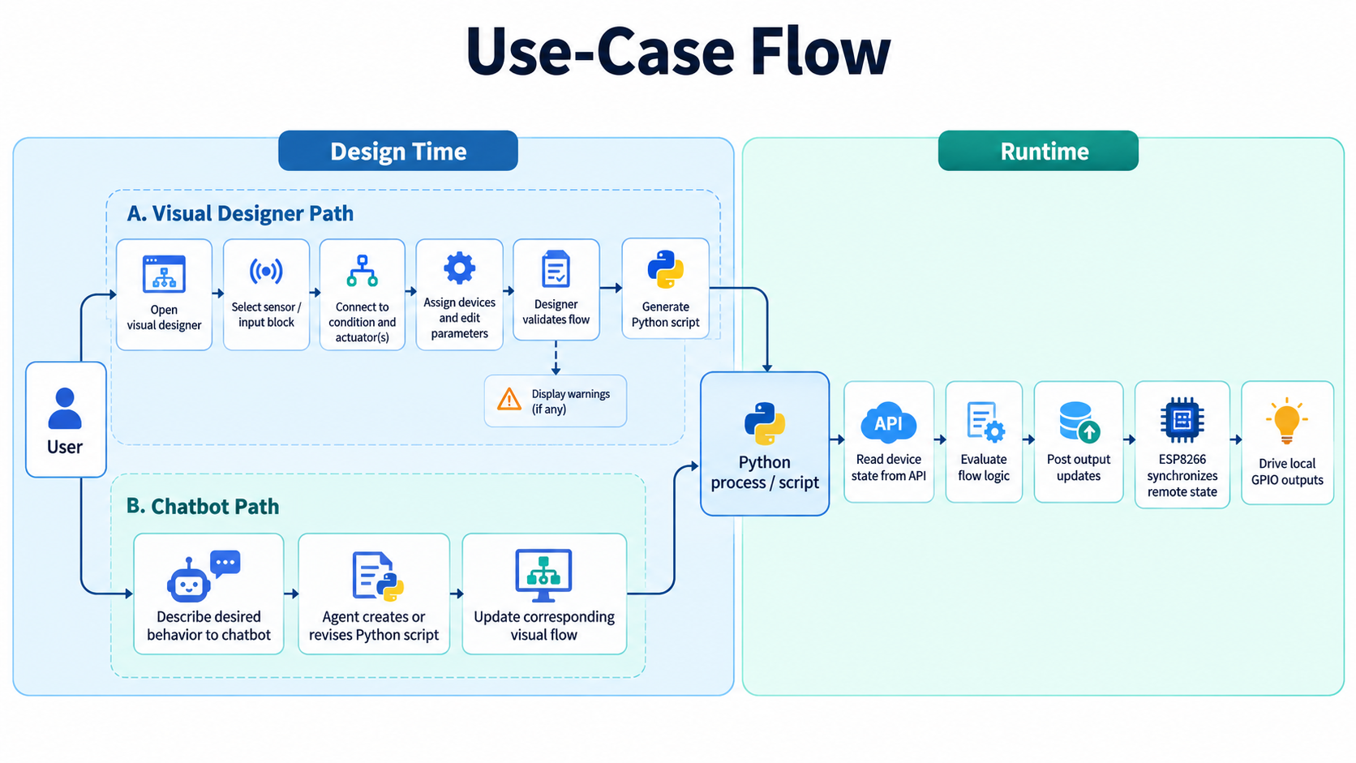
Figure 3.1. End-to-end system data flow.

3.5 Constraints and Assumptions
The website is accessed over HTTPS at the project URL. The embedded node communicates using Wi-Fi and HTTP endpoints, while remote server configuration is stored by the device firmware. The PHP API repository currently persists JSON files locally. The board export is a design artifact; it is not proof that a board was fabricated, assembled or electrically certified.
The project documentation identifies a mismatch between the new circuit and existing firmware. Until firmware is updated and tested, DHT11 and motion-sensor blocks must not be represented as validated on the current flashed firmware.

CHAPTER 4

SYSTEM AND HARDWARE DESIGN

4.1 Overall Architecture
The platform is organized into five cooperating layers. The physical layer contains the ESP8266 block and attached I/O. The firmware layer performs local sampling, output control, Wi-Fi configuration and synchronization. The API layer stores and serves device-state documents. The web layer presents device and flow state using React and React Flow. The automation and agent layer generates Python behavior and turns natural-language requests into corresponding designer and script edits.
The visual designer and the AI chatbot are authoring interfaces, not substitutes for the runtime. The Python automation process is responsible for executing the generated logic against the API. The device still applies its own GPIO mapping and local connectivity rules.
Layer | Main responsibility | Interface
Hardware | Sense inputs and drive indicators/actuators. | GPIO, sensor data and power connectors.
ESP8266 firmware | Wi-Fi setup, local HTTP I/O, device discovery and remote sync. | Local device endpoints and configured server URL.
PHP API | List devices and read/update JSON device state. | HTTP routes under /api/.
Web designer | Edit nodes/edges, configure blocks, show warnings and generated code. | React/React Flow application at iot.alsabid.com.
Python runtime and AI agent | Execute generated rules; translate chat requests into script/flow edits. | HTTP API, script lifecycle and designer state.
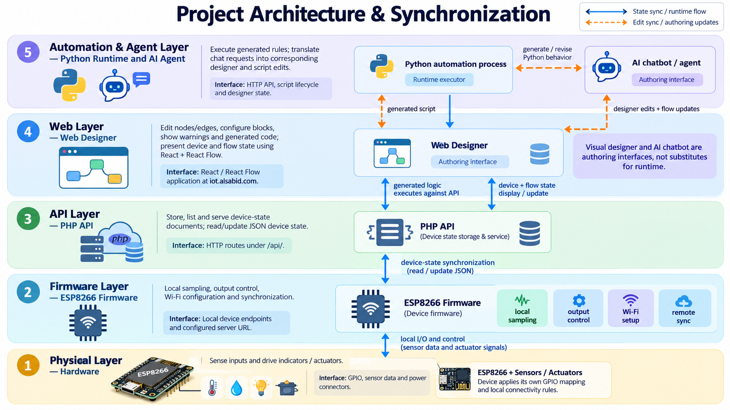

Figure 4.1. Layered architecture of the programmable-block platform.

4.2 Hardware Design
The supplied revised schematic places a Wemos D1 mini ESP8266 module at the center of the programmable block. Peripheral interfaces include a DHT11 connector, a three-pin motion connector, a two-pin button, an LED and a buzzer. The buzzer is switched with a BC547 NPN transistor so that the GPIO controls the transistor base rather than carrying the buzzer load current directly.
The drawing labels a 100-ohm resistor in the LED path and 4.7-kilohm resistors for signal conditioning/drive paths. It also shows a slide switch and power-module terminals labeled VCC, GND, OUT+, OUT-, B+ and B-. These labels should be reconciled with the exact module part number and complete netlist before fabrication. A 0-ohm link is also drawn; its electrical purpose should be confirmed in the source CAD design.
The following table records the interfaces visible in the current drawing. It is not a replacement for the authoritative CAD schematic, component datasheets or electrical rule check.
Reference/interface | Role in the design | Implementation note
U1: Wemos D1 mini | Wi-Fi controller and GPIO interface. | Firmware targets d1_mini_lite; currently configured pins are D1, D5, D6 and D7.
U3: DHT11 connector | Temperature/humidity sensor supply, data and ground. | Present in drawing; firmware currently uses OneWire/DallasTemperature instead.
CN1: motion sensor | Three-wire sensor interface. | Signal/polarity and sensor model require confirmation; motion processing is not in current firmware.
U4: button | User digital input. | Firmware maps button input to D1.
U5, R1: LED | Visual status/output indicator. | Firmware maps LED output to D6; schematic shows a 100-ohm series resistor.
BZ1, T1, R3: buzzer driver | Audible output switched by BC547. | Firmware maps buzzer output to D7; verify transistor pinout and buzzer rating.
U2, SW1, R4: power path | Power/module and switching connections. | Confirm module identity, battery chemistry, switch function and 0-ohm link against source CAD.

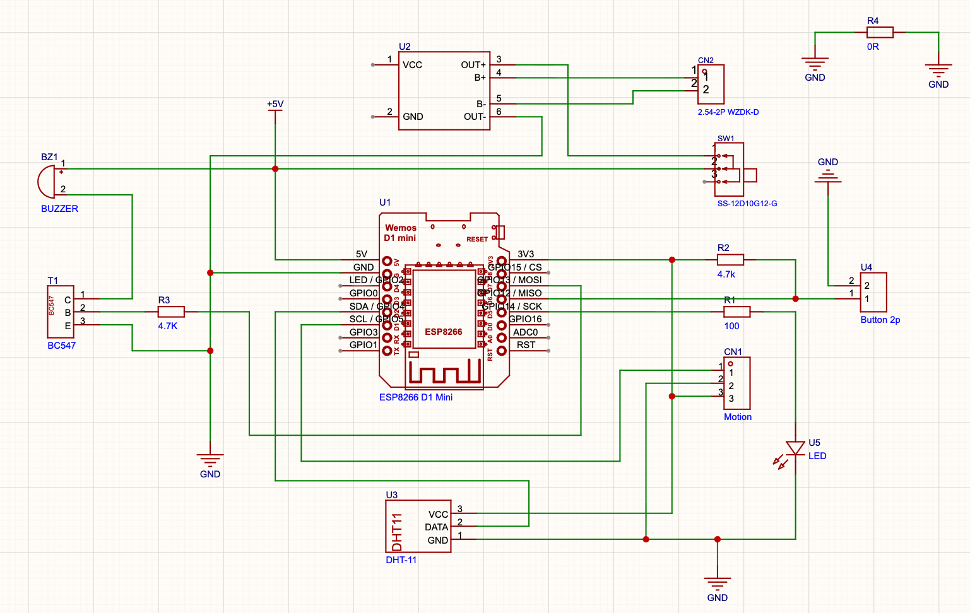

Figure 4.2. Revised circuit schematic.

4.3 PCB Layout
The dated PCB export shows the routed board layout and through-hole interfaces corresponding to the programmable-block design. The image below is taken from the local hardware PDF export rather than a generic web image. The visual export alone does not establish manufacturing clearance, copper thickness, current capacity, solder-mask details or design-rule compliance. Those checks should be performed on the native PCB project and fabrication outputs before ordering boards.
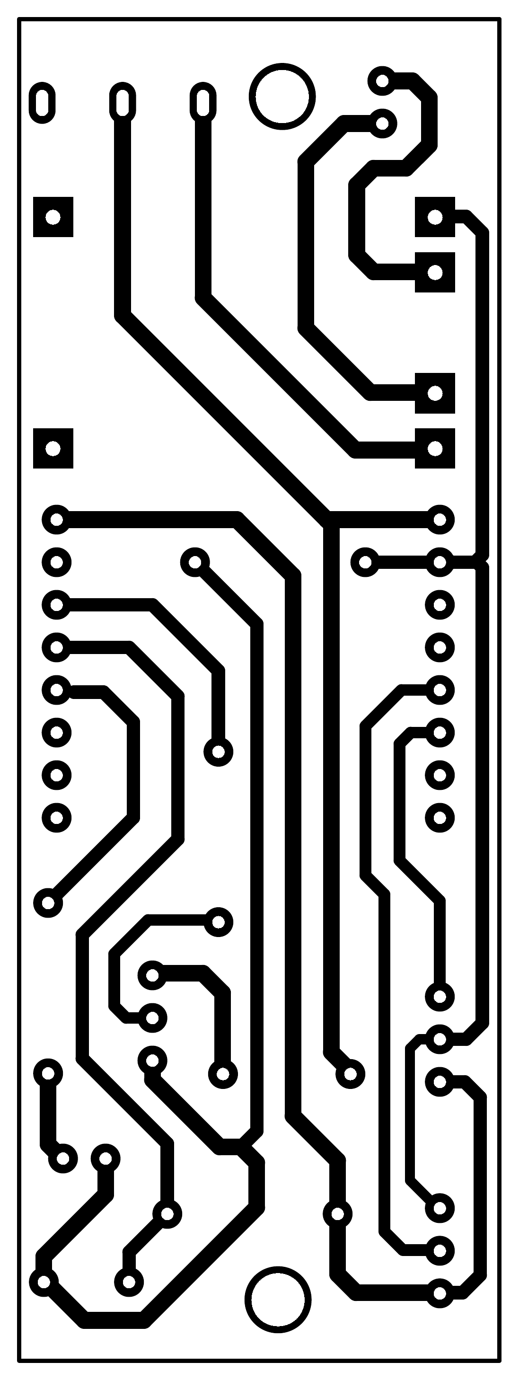
Figure 4.3. PCB layout, revision dated 27 September 2026. Source: project hardware export.

4.4 Software Architecture and State Model
The central API state document uses a device identifier and fields such as led, buzzer, button and tempC, with updatedAt and lastMethod metadata in the repository implementation. Boolean inputs accept common textual and numeric forms, and temperature accepts a finite number or null. Unknown device IDs are constrained to alphanumeric characters and hyphens before becoming file paths.
The API implementation uses one JSON file per device and writes state through a temporary file followed by rename. This is suitable for a small prototype but introduces file-system concurrency, backup, permissions, retention and scaling considerations. The public web application may have deployment features beyond the checked-in code; this report makes claims only about the inspected local implementation and publicly visible interface.
Entity | Representative fields | Purpose
Device state | deviceId, led, buzzer, button, tempC, updatedAt | Represents the latest state known to the API.
Visual node | node identifier, block type, device assignment, configuration | Represents a sensor, input, condition or action in a flow.
Visual edge | source node/port, target node/port | Defines data or control connections in a workflow.
Generated script | Python source derived from current graph and settings | Executes the workflow against the device API.
Agent edit | User request and proposed flow/script changes | Changes designer state and code; should be auditable.

CHAPTER 5

IMPLEMENTATION

5.1 Embedded Firmware
The PlatformIO configuration targets the ESP8266 D1 mini Lite and Arduino framework. The firmware starts a Wi-Fi access point and can connect as a station using saved router settings. A small configuration record is stored in EEPROM. When station connectivity is available, the firmware advertises a device hostname through mDNS and exposes local endpoints for setup, discovery and I/O.
The current pin mapping in src/main.cpp is D1 for the button, D5 for the optional one-wire temperature sensor, D6 for the LED output and D7 for the buzzer output. The onboard LED indicates connection status. Remote synchronization pulls desired state and pushes current state at intervals defined by firmware constants. The local API reports station connectivity, IP address and available I/O values.
This mapping does not yet match all sensors in the updated schematic. The firmware imports OneWire and DallasTemperature and does not implement DHT11 decoding or a motion-sensor signal. Firmware changes, pin conflict review, sensor libraries and hardware tests are prerequisites to claiming those functions as implemented.

5.2 PHP Device API
The repository server-api/index.php routes requests to a device collection or a single device record. GET /api/devices lists saved records; GET /api/{deviceId} returns the device state; GET or POST /api/{deviceId}/set updates supported fields. The implementation accepts JSON and form/query values, validates Boolean and temperature fields, updates a timestamp and writes a JSON file under the devices directory.
The endpoint sends permissive cross-origin headers and the checked-in implementation contains no authentication or authorization layer. These properties must be treated as prototype limitations. A production deployment should authenticate users and devices, authorize per-device operations, narrow allowed origins, use TLS consistently, rate-limit writes and protect server-side state files.

5.3 React Visual Designer
The website presents a visual programming studio using a left-to-right flow canvas. Visible block groups include inputs, sensors, logic and actuators. The observed sensor examples include temperature, humidity and light-level inputs; input examples include a button and timer; logic includes conditions; actuator examples include LED, buzzer, relay and email alert. A selected block can be inspected and configured, and the editor shows flow warnings and a generated script panel.
The visual flow is intended to remain editable after script generation. The application also displays connected-device counts and reports live synchronization with the API. The exact persistence schema and deployment internals are not inferred from the public UI.
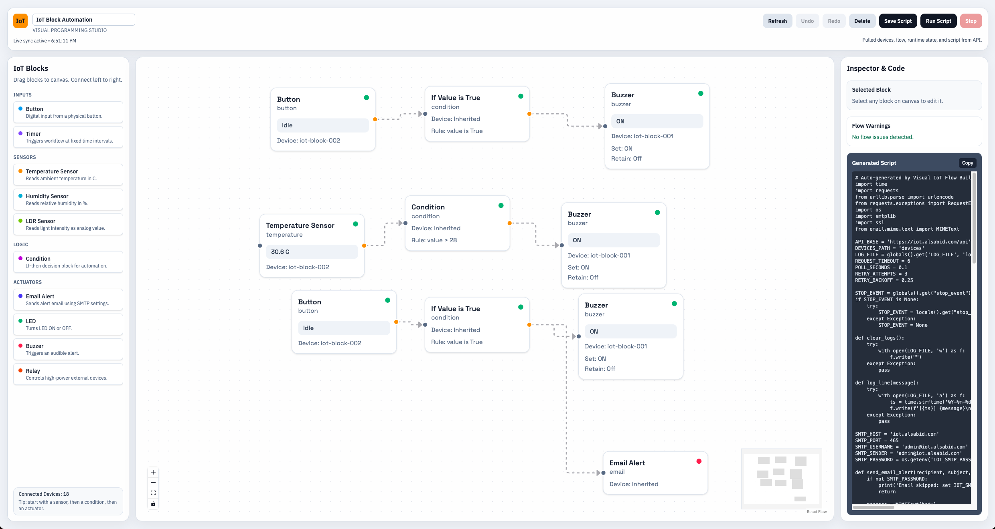
Figure 5.1. React Flow visual designer.

5.4 Generated Python Automation
The website displays Python code generated from the flow graph. The observed script uses HTTP requests to read device collections and post output changes. It contains bounded request timeouts, retries with backoff, a polling interval, file-based logs, an optional stop event and an SMTP configuration read from an environment variable. The code tracks prior output values to avoid repeating unchanged writes and maintains flags for one-shot email alerts.
The separate checked-in iot-block-v2 Python client provides device discovery over mDNS, status reads, output commands and explicit error classes. These are related but distinct code surfaces: the client library is repository code, while the deployed designer’s generated script may evolve independently. They should be tested against the same versioned API contract.
Figure 5.2. Generated Python script in the designer.

5.5 AI Chatbot as an Editing Agent
The project includes a website chatbot that accepts a natural-language automation request and can write or revise the Python script while updating the visual designer automatically. At the product level, this joins language-based authoring with a structured visual workflow: the graph remains available for inspection, and the generated script reflects the requested automation.
An agent update should be treated as a coordinated change to at least two representations: the visual graph and the executable Python. The system should preserve a mapping between nodes and code regions, validate device assignments and types, surface warnings, and keep undo/history available. If the script can execute automatically, sandboxing and an explicit runtime policy are also required.
No model name, vendor, prompt, tool protocol, evaluation result or approval mechanism is asserted here because those implementation details were not provided or verified. The capability is described as a project feature, while the associated safety controls remain requirements for further evaluation.
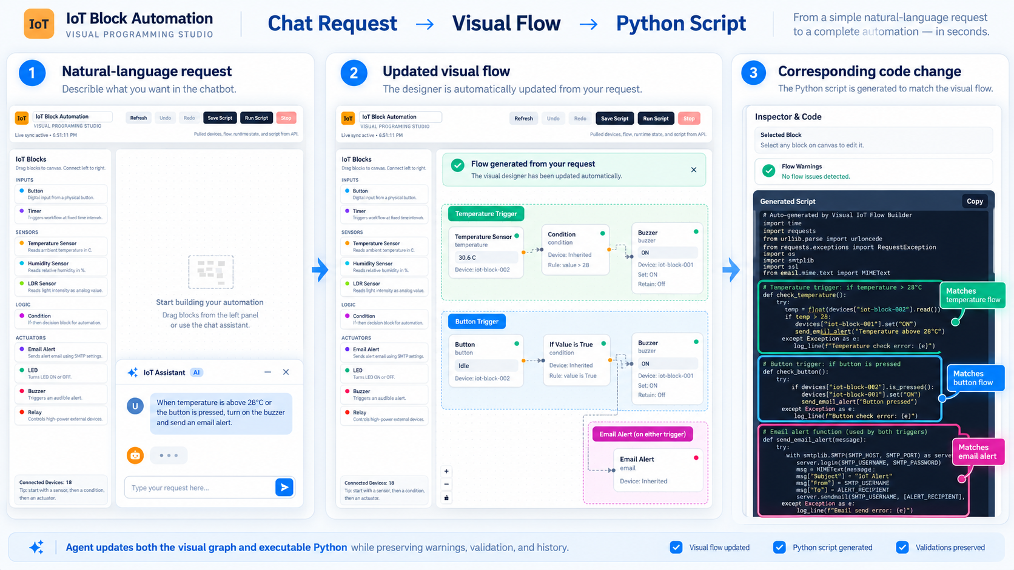
Figure 5.3. AI chatbot updating a workflow and its script.

5.6 End-to-End Runtime Sequence
At startup, the device loads its configuration, starts the access point and attempts station connection when credentials exist. The firmware services local HTTP requests and periodically synchronizes with the configured remote host. The API exposes the current device record to the web application and automation process. The designer supplies a graph; its generated Python script polls state, evaluates the graph logic and posts output changes. The device consumes updated output state and drives its GPIOs. The chatbot can modify the graph and script through the website editing workflow, after which the user can inspect the resulting representation.

CHAPTER 6

VERIFICATION AND EVALUATION

6.1 Verification Method
Verification is divided into document/code review, API tests, firmware tests, workflow-generation tests, agent consistency tests and physical-board tests. Evidence should identify the tested firmware revision, server revision, designer build, hardware revision, network conditions and test inputs. A successful response from one layer does not prove the complete end-to-end system.

6.2 Current Evidence and Test Status
Area | Check | Evidence status
DOCX/documentation | New thesis package structure and image relationships. | Formal OOXML schema validation passed for the prior report; this new document must also be validated before submission.
PHP API | Device list, read, valid update, invalid Boolean/temperature and unsupported route. | Routes and validation logic are present in source; execution test results not supplied.
ESP8266 firmware | AP setup, STA join, discovery, I/O, sync and reboot/config persistence. | Implementation visible in source; hardware test results not supplied.
Visual designer | Create/connect/configure blocks, warnings, save/load and code generation. | Public interface observed; automated regression results not supplied.
Python runtime | Polling, retries, stop behaviour, API failure and output writes. | Generated code and client implementation inspected; execution test results not supplied.
AI agent | Graph/script consistency, invalid request, undo/history, safe execution. | Feature stated by project owner; controlled test evidence not supplied.
PCB/hardware | Design-rule check, fabrication, continuity, supply, sensor and output tests. | PCB PDF available; native CAD checks and assembled-board results not supplied.

6.3 Recommended Integration Tests
- Confirm the board revision and schematic netlist agree on every connector pin, supply rail, GPIO mapping and resistor reference.
- Run the firmware against the exact sensors installed on the board. Verify DHT11 and motion operation only after corresponding firmware support has been implemented.
- For the PHP API, test allowed methods, device identifier validation, missing fields, invalid values, JSON persistence, concurrent updates and file permission failures.
- For each visual block type, verify the configured graph produces code with the same device, field, threshold and action values shown in the inspector.
- For AI-assisted edits, compare the graph before and after the request, compare generated code, verify undo, and test malformed, ambiguous and unsafe requests.
- Exercise disconnect and reconnect paths across the device, API and automation runtime. Confirm failures are visible and outputs reach a defined safe state.
- Review CORS, authentication, authorization, TLS, secrets handling, SMTP configuration and execution isolation before external deployment.

6.4 Security, Privacy and Operational Risks
The PHP source sets Access-Control-Allow-Origin to an unrestricted wildcard and does not implement authentication in the reviewed route. Device identifiers are validated for path safety, but identifier validation is not access control. The device configuration contains Wi-Fi credentials in EEPROM, and the generated email example includes environment-based SMTP password handling. These areas require threat modeling and operational safeguards.
The AI agent can change executable automation. Risks include incorrect logic, unintended actuator activation, exposure of personal data in prompts or logs, prompt injection through user-provided content, and generated code containing unsafe operations. A production system should validate a typed workflow representation, constrain code generation to supported operations, apply least privilege, retain auditable diffs and enforce a controlled execution boundary.
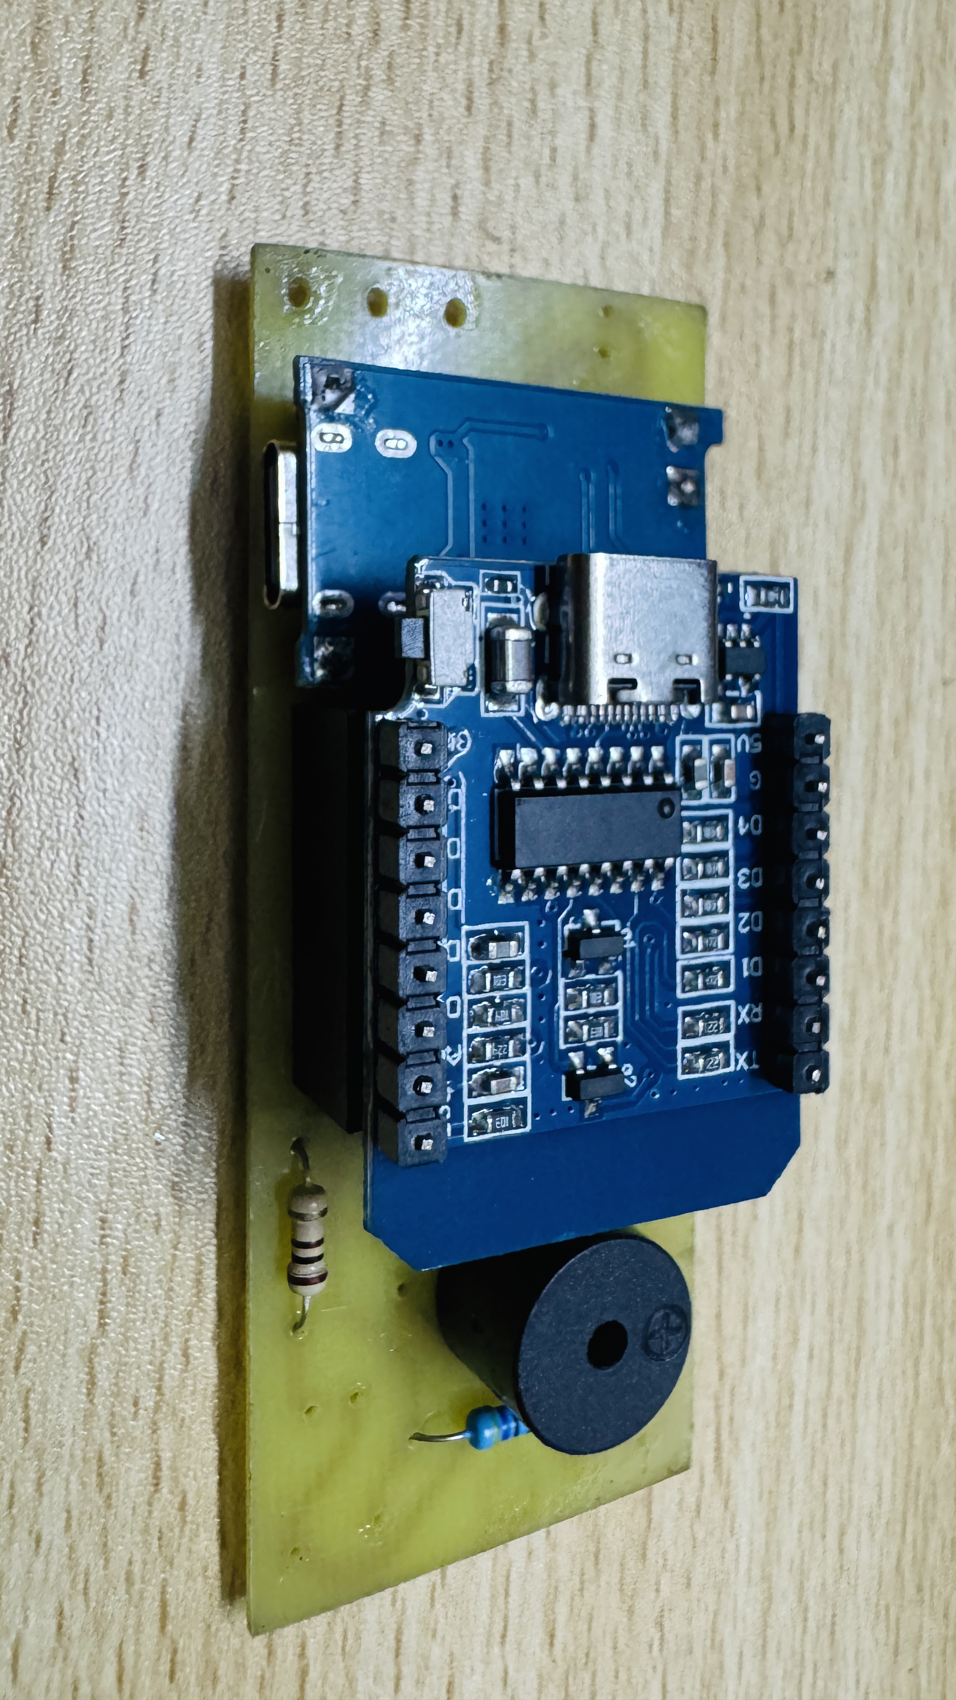

Figure 6.1. Assembled prototype and bench test setup.

CHAPTER 7

CONCLUSION AND FUTURE WORK

7.1 Conclusion
The IoT Real World Programmable Blocks project combines an ESP8266-based physical node with a web-based automation environment. Its current product concept links sensor and actuator blocks in a React Flow designer, generates Python automation, exchanges state through a PHP JSON API and supports a website chatbot that edits both the script and the visual workflow. A dated PCB layout provides a concrete hardware revision for the block.
The report distinguishes the intended circuit from the firmware currently in the repository. The revised schematic includes DHT11 and motion-sensor interfaces, while the firmware is presently configured for a one-wire temperature sensor on D5 and does not process motion input. The system should therefore be considered an evolving prototype rather than a fully integrated, production-ready platform. Formal validation of the previous report and repository inspection provide documentation evidence, but no physical performance or user-study results are claimed.

7.2 Future Work
- Update firmware for the current schematic, define exact pin assignments and add DHT11 and motion-sensor support where intended.
- Run electrical-rule checks on the native schematic and PCB, confirm power-module and battery ratings, and test fabricated hardware before publication.
- Version the API, visual graph schema, firmware signal definitions and script generator as a shared contract.
- Add authentication, per-device authorization, restricted CORS, secure transport, rate limiting and protected state storage.
- Add AI change previews, graph/script consistency checks, undoable history, audit records and restricted script execution.
- Build automated tests for API routes, code generation, supported block combinations and agent-driven updates.
- Conduct a documented usability study and measure workflow completion time, error rates, API latency and device reconnection behaviour.
- Replace all figure placeholders with approved, high-resolution project assets and update captions, alternative text and the final table of figures.

REFERENCES
[1] Espressif Systems. ESP8266EX documentation and technical resources. https://www.espressif.com/en/products/socs/esp8266ex/resources (accessed 30 September 2026).
[2] ESP8266 Arduino Core. Documentation. https://arduino-esp8266.readthedocs.io/ (accessed 30 September 2026).
[3] React. Official documentation. https://react.dev/ (accessed 30 September 2026).
[4] React Flow. Official documentation. https://reactflow.dev/ (accessed 30 September 2026).
[5] PHP Group. PHP Manual. https://www.php.net/manual/en/ (accessed 30 September 2026).
[6] PlatformIO. Espressif 8266 platform documentation. https://docs.platformio.org/en/latest/platforms/espressif8266.html (accessed 30 September 2026).
[7] Python Software Foundation. Python 3 documentation. https://docs.python.org/3/ (accessed 30 September 2026).
[8] IoT Programmable Blocks visual designer. https://iot.alsabid.com/ (accessed 30 September 2026).
[9] Project source files: platformio.ini, src/main.cpp, server-api/index.php, iot-block-v2/blocks_lib.py, hardware/PCB_PCB1_2026-09-27.pdf and the supplied revised circuit schematic. Sabid-MSc project repository, reviewed 30 September 2026.

APPENDIX A

API AND DATA REFERENCE

A.1 PHP Remote API
Method and route | Purpose | Notes
GET /api/devices | List state records known to the PHP API. | Returns count and devices array.
GET /api/{deviceId} | Read one device record. | Creates a default state if the record does not exist.
GET /api/{deviceId}/set?... | Update supported state fields. | Query values are accepted by the checked-in implementation.
POST /api/{deviceId}/set | Update supported state fields. | Accepts JSON or form data.
OPTIONS | CORS preflight handling. | Review wildcard origin policy before deployment.

A.2 Device State Example
{
"deviceId": "iot-block-002",
"led": false,
"buzzer": false,
"button": true,
"tempC": 27.31,
"updatedAt": "2026-09-30T12:00:00Z"
}

A.3 ESP8266 Local API
Route | Purpose
GET / | Serve the local Wi-Fi setup page.
POST /save | Save router credentials and optional server URL.
GET /api/discovery | Return device identity, hostname and connection/sync status.
GET /api/io | Read local I/O state when the station is connected.
GET or POST /api/io/set | Set LED and/or buzzer output state.

APPENDIX B BUILD AND SETUP PROCEDURE

B.1 Firmware Build
- Open the project folder with PlatformIO.
- Review platformio.ini and confirm the target board and library versions.
- Build using platformio run.
- Connect the target board, select the correct upload port and upload using platformio run -t upload.
- Use the serial monitor at 115200 baud to inspect startup and network messages.

B.2 First Device Setup
- Power the block and connect to its configured setup access point.
- Open the device setup page at http://192.168.4.1.
- Enter router SSID and password; set the server URL only when the intended API is reachable.
- Reboot and confirm station connection and discovery information.
- Test each local input and output before running a remote automation.

B.3 Operational Notes
- The repository firmware default device identifier is IoT-Block-002.
- Firmware pin assignments are D1 button, D5 one-wire temperature, D6 LED and D7 buzzer.
- The new schematic describes DHT11 and motion connections that are not yet implemented by the inspected firmware.
- Do not place Wi-Fi or SMTP passwords in source control, screenshots or thesis figures.
- A default/demo access-point password visible in earlier project documentation should be changed before deployment.

APPENDIX C FIGURE INSERTION CHECKLIST
Figure | Required asset | Source / preparation
3.1 | End-to-end system data flow diagram. | Create from the final verified deployment architecture.
4.1 | Layered system architecture. | Create from current firmware, API, designer, Python runtime and agent interfaces.
4.2 | Updated circuit schematic export. | Export the supplied current schematic from its native CAD file at readable resolution.
4.3 | PCB layout. | Embedded from hardware/PCB_PCB1_2026-09-27.pdf.
5.1 | React Flow visual designer screenshot. | Capture actual website UI; remove personal/device data.
5.2 | Generated Python script screenshot. | Capture generated code from the current website; redact addresses/secrets.
5.3 | AI agent interaction. | Capture a real prompt and resulting flow/code update, with test context.
6.1 | Assembled hardware and test setup. | Photograph the current revision and list supply, sensors and measured conditions.

No Google-search images were inserted. Generic component photos would not document this specific circuit or product interface; use project-owned captures or properly licensed, attributed images only where a project-specific asset is unavailable.

